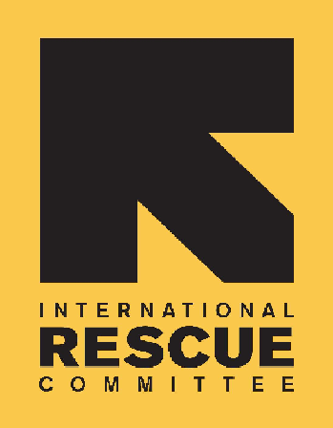
INTERNATIONAL RESCUE COMMITTEE, INC.
SUDAN

BID NOTICE

Construction Contract for Latrines and Bathing Shelters

The International Rescue Committee, hereinafter referred to as “the IRC”, is a non-profit, humanitarian agency that provides relief, rehabilitation, protection, resettlement services, and advocacy for refugees, displaced persons and victims of oppression and violent conflict.

The IRC Sudan program invites proposals from interested bidders for the provision of latrines and bathing shelters construction for Gedaref.- Tunaybah Camp IRC will sign a construction agreement with the successful bidder.
- CONSTRUCTION OF SEVENTEEN (17) TWO STANCE IMPROVED LATRINES IN BLOCK H AT TUNAYBAH REFUGEE CAMP, GEDAREF STATE.
- CONSTRUCTION OF TWENTY-THREE (23) IMPROVED BATH SHELTERS IN BLOCK H AT TUNAYBAH REFUGEE CAMP, GEDAREF STATE.

Interested and suitably qualified suppliers may download the RFP documents with the required tender information and Specifications from the Sudan Bids or request complete tender information using e-mail SU-KhartoumProcurment@rescue.org during office hours 9:00 AM – 3:00 PM from 8th Feb, 2022 to 13th Feb , 2022.

Bidder shall submit bids addressed to the PROCUREMENT COMMITTEE, via email address IRC Tender tender.ircsdn@rescue.org latest 4:00PM (Local Time in Sudan) on March 1, 2022.

Bids can also be physically submitted to the IRC office in Khartoum at Block 22, Plot 43, Bader Street, Khartoum, Sudan latest 4:00PM (Local Time in Sudan) on March 1, 2022 or House # 241, Block 15, Al-Salamaby Area, Gedaref, Gedaref State. latest 4:00PM (Local Time in Sudan) on March 1, 2022.

IRC believes in integrity, service & accountability,
IRC has Zero tolerance to corruption and provides equal opportunity.

